NAME: Iago Yuri Rossan - DSM 5°Semester
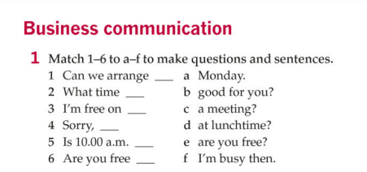
Resposta:
1 — c: Can we arrange a meeting?
2 — e: What time are you free?
3 — a: I’m free on Monday.
4 — f: Sorry, I’m busy then.
5 — b: Is 10.00 a.m. good for you?
6 — d: Are you free at lunchtime?

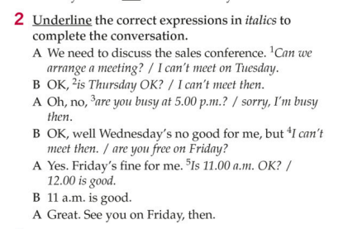

Respostas:
A: We need to discuss the sales conference. Can we arrange a meeting?
B: OK, is Thursday OK?
A: Oh, no, sorry, I'm busy then.
B: OK, well Wednesday's no good for me, but are you free on Friday?
A: Yes. Friday's fine for me. Is 11.00 a.m. OK?
B: 11 a.m. is good.
A: Great. See you on Friday, then.

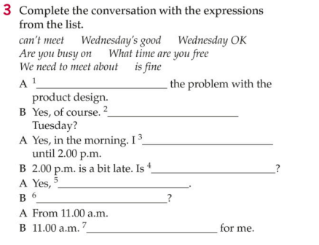
Respostas:
A: 1.We need to meet about the problem with the product design.
B: Yes, of course. 2.Are you busy on Tuesday?
A: Yes, in the morning.I 3.can't meet until 2.00 p.m.
B: 2.00 p.m. is a bit late. Is 4. Wednesday OK?
A: Yes, 5. Wednesday's good.
B: 6. What time are you free?
A: From 11.00 a.m.
B: 11.00 a.m. 7. is fine for me.

